**Jupyter Notebooks**

Hello everyone and welcome to the Jupyter Notebook’s lecture and this lecture I will be showing you how to effectively use the Jupyter Notebook system and giving you a tour of the overall environment. Also check out the resources for this lecture in order to download the zip file that contains all the notebook files. It contains all the *.ipynb* files and notebooks for the course. Make sure to remember where you saved and unzipped the files. Let’s go ahead and explore the notebooks as well as get a feel for how to effectively use them. I’m going to go ahead and just remind you how you can open up a Jupyter Notebook. Here I am at by command prompt and as a reminder if you’re using MAC OS go ahead and just use your terminal for this. If you are using Windows just go ahead and come over here and type in CMD in Search or Run commands. You can also use the **Anaconda Command Prompt** that comes with the Anaconda distribution. All right!

So you go ahead and come to the command prompt and then type *jupyter* [space] *notebook* and hit enter. Keep in mind this is going to start a Jupyter Notebook wherever you are in the command prompt. See Figure 1 below.

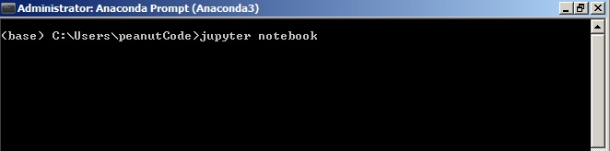

**Figure 1**. Starting Jupyter Notebook

After hitting ‘Enter’, you will see Jupyter Notebook on your browser. Here it is! (See Figure 2)

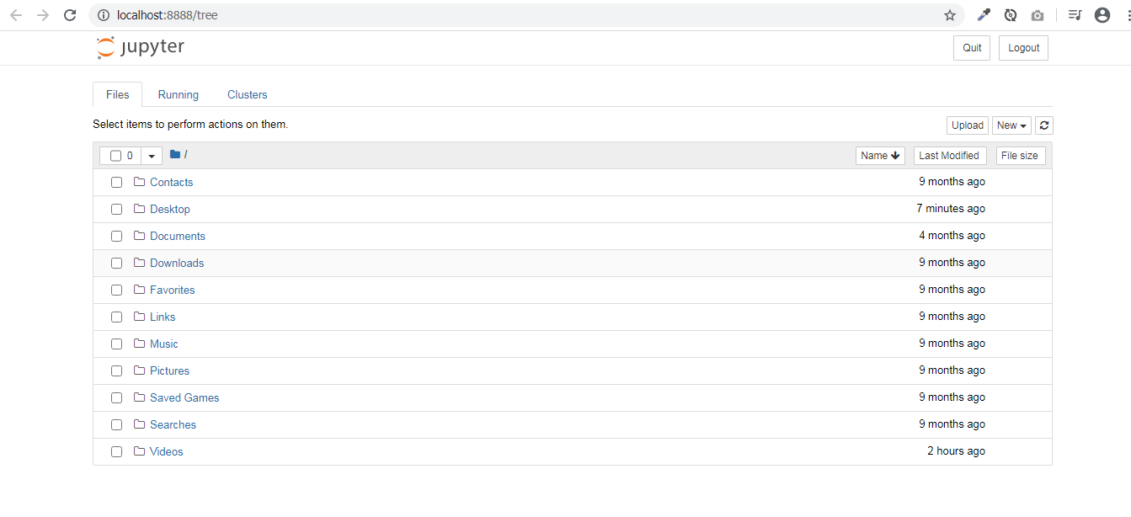

**Figure 2**. Jupyter Notebook IDE

Go ahead and find where you actually saved the unzipped files. In the exercise files, you will see quite a few folders. For the very first lecture go to ‘Python Crash Course’ folder and open up the *Python Crash Course.ipynb.* Pretty much for every lecture where you see me coding something out there is a folder that has the overall section name and then they’ll be a subfolder of the actual section name and then the notebook files which correspond to the lecturer names. So the very first one is ‘Python Crash Course’, you can go ahead and click on this. They will take a little time to load and then everything I will be typing out throughout the lecture is here for you and pretty much at the beginning of every section of the course. Do not worry for I will remind you on where you can find the actual notebooks for that section of the course. There are quite a few lectures and it may be hard to find sometimes but I will be there to guide you and if you have any questions on where to find things just feel free to post a question

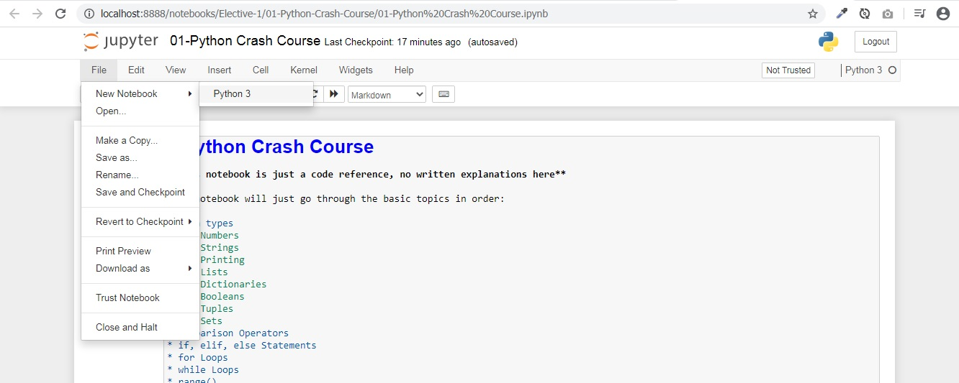All right then after that we will start Python for Data Science and Analysis. Let me go ahead and just walk through how the Jupyter Notebook system works in a general sense. I am going to go all the way back up to the master file and then I am going to click File then ‘New Notebook’ (Figure 3). I am going to click Python or Python 3 or whatever version you have in your computer and it should be fine.

**Figure 3**. Creating a new Notebook

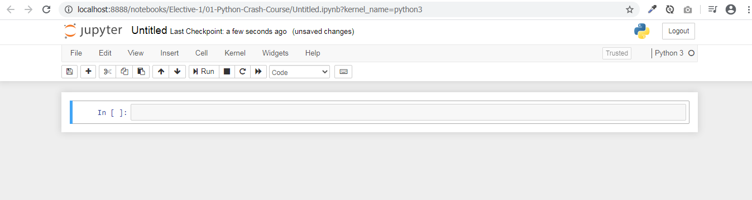After doing the procedure, you will get something like this (Figure 4). To rename a notebook, just click on the ‘Untitled’ text and name the notebook whatever you want. (Try renaming it to my ‘My Notebook for instance)

**Figure 4**. A New Notebook

You are doing great! Let me show you the basics. This is a code cell which means I can type in Python code into the cell and then run it as a very basic example. I can say *print(‘hello’)* and then I can run the cell by clicking here on run and I will go ahead and run and show me the output below the cell (Figure 5).

I can also do the same thing for basically any Python code if I wanted to know what one plus one is. I just click run here and it shows me the output in the cell. Notice that since I printed the output of ‘hello’ it actually print the text compared to the one plus one that did not show out since I did not actually specify to print the output (Figure 5).

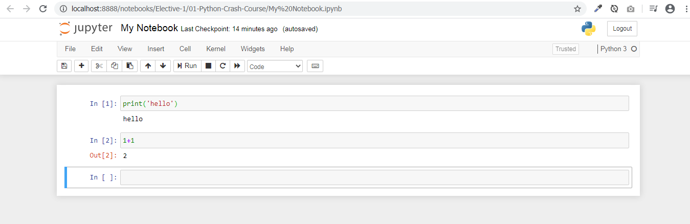

**Figure 5**. Code Cells and Output

You don’t always have to come up and click the ‘Run’ cell. What you can do is to actually just to *[Shift]* + *[Enter]* on your keyboard. So keep that in mind that is a really and fast way to just run codes in a cell quickly and it can save you a lot of time. Another little trick is *[Alt] + [Enter]* that will actually insert a cell below it as well. That is a really nice trick and I’ll show you why later on when we discuss exercises.

Now you may be wondering how I can save this notebook. You can either do [CTRL] + [S] or click on the little floppy disk icon save. It also has an auto-save feature which triggers for about 2 minutes. Another way is to go to ‘File’ and ‘Save any Checkpoint’. In terms of downloading a file into a different format, a bunch of options can be selected (‘File’ – ‘Download As’).

Something else I want you to know is if you every have for instance of an infinite loop running and let’s just say this is like running forever and you want to somehow restart your kernel. (Go to ‘Kernel’ – ‘Restart’). Basically what happens is the notebook is connected to a kernel and a kernel is kind of just an instance of Python running. And if something is wrong where Python is crashing maybe you actually wrote a script that just infinitely loops or takes a really long time to execute. You can always just stop everything by coming over to ‘Kernel’ and clicking ‘Restart’. If you every need help in addition to everything I just told you here you can always just click ‘Help’ and then they will give you help on a lot of the libraries that we are going to be working with as well as notebook help. I suggest also exploring the keyboard shortcuts that are available to you in the ‘Help’ section of the notebook.

All right! That is really the basics of the notebook and pretty much all you need to know as far as you go through this course.

Real quick I wanted to show you what exercises look like throughout this course. So for instance let’s say you go a python for data analysis and you are on the NumPy section. You have done the lectures and you’re ready to begin the exercise. Every exercise files can be found on the master file. Exercise file will have questions for you and then a cell where you can go ahead and answer those questions and a lot of times. I’ll also show you the expected outputs.

So for instance here you want to create an array of zeros and I know you probably don’t know how to do that yet but keep in mind that if you start typing code or texts in the cell such as print ‘hello’ and runt this you will overwrite the output. Keep that in mind and there will be more relevant when you actually get to the exercises. Some of you may be wondering if you open an exercise file that actually shows text and is not a code cell. This is known as a markdown cell. A really nice way to take notes as you go along throughout the lectures and this also supports a markdown formatting. That is it for Jupyter Notebooks!

Just keep in mind again that the Jupyter Notebook system will start wherever you were in your command prompt or your terminal. You have to enter command prompt commands if you want to change your directories.

All right thanks everyone and I will see you on the next lecture.